Chapter 10, Solution 19.

We have a supernode as shown in the circuit below.
j2 W
0.2 V_{o}
2 W
4 W
V₁

V₃

V₂

+
V_{o}
-

-j4 W

Notice that 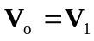.

At the supernode,
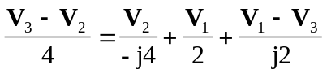
(1)
At node 3,
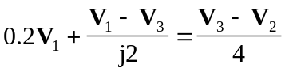
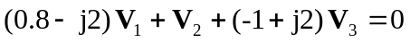 (2)

Subtracting (2) from (1),
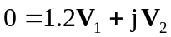 (3)

But at the supernode,
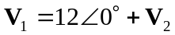
or 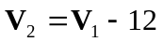 (4)

Substituting (4) into (3),
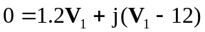
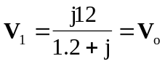

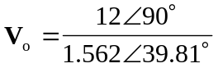
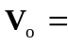 7.682Ð50.19° V

